

ASSIGNMENT

TECHNOLOGY PARK MALAYSIA

Intake code: APDMP2401AI

Group assignment In Pattern Recognition
Student ID | Student Name
TP079177 | Mohamed Mohamed Said Aly Amin
TP 079740 | LOH WEI CHUN

Lecturer Name: ASSOC. PROF. DR. V. SIVAKUMAR .

Classification of Breast Cancer Histopathology Images Using Traditional Machine Learning: A Comparative Study of SVM, Random Forest, and XGBoost

A report submitted in fulfilment of the
requirements for the module
Pattern Recognition

Asia Pacific University of Technology & Innovation (APU)
School of Computing and Technology

January 2026

Table of Contents

Table of Contents 3
List of figures 5
List of tables 6
1. Abstract 7
2. Problem Statement 8
3. Objectives 8
4. Proposed Algorithm and Implementation 9
4.1 Dataset Description 9
4.2 System Architecture and Implementation 9
4.2.1 Research Innovation and Motivation 9
4.2.2 Core System Architecture 10
4.2.3 Multi-Pathway Detection Architecture 11
4.2.4 System Performance Specifications 12
4.3 System Design Justification 12
4.4 System Evaluation Framework 13
4.5 System Usage and Command Line Interface 14
4.5.1 Directory Structure and Data Management 14
4.5.2 Command Line Interface and Operations 15
5. Experimental Results 16
5.1 Performance by Category 16
5.2 Detection Performance 17
5.3 Segmentation Accuracy 18
5.4 Recognition Success Rate 19
5.5 Robustness to Environmental Factors 20
6. Critical Evaluation and Analysis 21
6.1 System Strengths 21
6.2 Failure Modes 21
6.3 Potential Improvements 22
7. Conclusion and Recommendations 23
7.1 Conclusion 23
7.2 Future Work and Research Directions 23
8. References 24
9. Appendix 25
A. System Output Demonstrations 25
A.1 Bar Code Detection 25
A.2 QR Code Detection: 26
A.3 Mixed Bar Code – QR Code Detection 28
B. Pseudocode for Key Algorithms 29
B.1 Multi-Method Detection Pipeline 29
B.2 Adaptive Preprocessing 29
B.3 Multi-Scale Gradient Detection 30
B.4 QR Code Grid-Based Detection 30
B.5 Multi-Orientation Recognition 31
B.6 False Positive Filtering 31
B.7 Comprehensive Performance Evaluation 32
C. Parameter Sensitivity Analysis 33
D. Code Snippets for Key System Components 34
D.1 Code Snippet 1 - Adaptive Multi-Scale Preprocessing Pipeline 34
D.2 Code Snippet 2 - Intelligent Boundary Refinement with Multi-Epsilon Approximation 35
D.3 Code Snippet 3 - Grid-Based QR Code Detection with Spatial Decomposition 36
D.4 Code Snippet 4 - Multi-Orientation Recognition with Gradient-Based Rotation Analysis 37
D.5 Code Snippet 5 - Comprehensive Performance Evaluation Framework 38

List of figures

Figure 1 - System Directory Structure 14
Figure 2 - Detection performance metrics across all code categories 17
Figure 3 - Segmentation Accuracy by Code Type 18
Figure 4 - Recognition Success Rate and Average Decoding Time 19
Figure 5 - EAN13 detection on cylindrical container surface with bright lighting. 25
Figure 6 - EAN13 barcode detection on flipped and angled surface 25
Figure 7 - EAN13 barcode detection despite bright lighting reflection 25
Figure 8 - EAN13 barcode detection despite partial blocking and red colour overlay. 26
Figure 9 - CODABAR barcode detection overcomes vertical inversion 26
Figure 10 - QR code detection on rotated code orientation 26
Figure 11 - QR code detection overcomes small size on distant triangular sign 27
Figure 12 - QR code detection successful despite reflective glare and angled orientation 27
Figure 13 - Simultaneous detection of multiple QR codes in single image frame 27
Figure 14 - CODABAR barcode and QR code detected together in mixed-code image 28
Figure 15 - Multi-code detection - 2 EAN13 barcodes and 1 QR code identified together 28
Figure 16 - Quad code detection successful - 2 barcodes and 2 QR codes recognized simultaneously 28

List of tables
Table 1 - System Technical Architecture and Performance Specifications 12
Table 2 - Performance of detection results across all code categories 16
Table 3 - Comprehensive detection performance metrics across all code categories 17
Table 4 - Comprehensive segmentation accuracy metrics, across all code categories. 18
Table 5 - Comprehensive Recognition Performance Analysis Across Code Categories 19
Table 6 - Parameter Sensitivity Analysis 33

Abstract
Breast cancer remains one of the leading causes of cancer-related mortality among women worldwide, with accurate histopathological diagnosis being critical for treatment planning and patient outcomes.
This study presents a comprehensive pattern recognition system for automated classification of breast histopathology images into benign and malignant categories using traditional machine learning approaches.
Researchers implemented a complete pipeline on the BreakHis dataset (100X magnification), comprising 1,078 training and 194 test images with patient-disjoint splitting to prevent data leakage.
The methodology involved a 10-stage preprocessing pipeline, extraction of 2,767 multi-modal features through six methods (HOG, GLCM, LBP, Gabor filters, intensity histograms, and statistical descriptors), and a comprehensive feature selection strategy combining seven complementary techniques (variance filtering, correlation filtering, ReliefF, F-Score, RFE, tree-based importance, and LASSO regularization) to identify the most discriminative 400 features.
Three classifiers were systematically compared: Support Vector Machine with RBF kernel, Random Forest, and XGBoost, with hyperparameters optimized through 3-fold cross-validation. Random Forest and XGBoost achieved the best performance with 69.6% accuracy, 78.4% specificity, and AUC of 0.784, while SVM reached 63.9% accuracy.
Although sensitivity (60.8%) indicates room for improvement in detecting malignant cases, the models demonstrated interpretable feature importance rankings that align with known pathological characteristics—GLCM texture features and morphological descriptors emerged as most discriminative.
This work demonstrates that traditional machine learning, despite lower performance compared to deep learning benchmarks (85-90%), offers valuable interpretability and computational efficiency for computer-aided diagnosis in resource-constrained settings, with potential deployment as a screening tool or second-opinion system for pathologists.
The complete implementation, source code, and experimental datasets are publicly available at: https://github.com/msaid1976/BreastCancerHistopathological

Keywords:
Breast cancer, histopathology, pattern recognition, machine learning, SVM, Random Forest, XGBoost, feature selection, medical image analysis, computer-aided diagnosis

Introduction
Breast cancer represents a major global health challenge, accounting for approximately 2.3 million new cases and 685,000 deaths annually according to the World Health Organization (WHO, 2020). Early and accurate diagnosis is paramount for improving patient survival rates and treatment outcomes. The diagnostic gold standard remains histopathological examination of tissue samples, where pathologists analyze microscopic images of hematoxylin and eosin (H&E) stained tissue sections to distinguish between benign and malignant lesions (Elmore et al., 2015). This process, while highly accurate when performed by experienced pathologists, is inherently time-consuming, subjective, and prone to inter-observer variability—studies have shown disagreement rates of up to 25% among pathologists for borderline cases.
The traditional diagnostic workflow in breast pathology involves multiple labor-intensive stages: tissue fixation, paraffin embedding, microtome sectioning (4-5 μm thickness), H&E staining, and microscopic examination at various magnifications. Pathologists must assess numerous morphological features including nuclear size and shape, chromatin patterns, cellular architecture, mitotic activity, and overall tissue organization. For a single patient, this evaluation can take 15-30 minutes per slide, and with increasing caseloads in clinical laboratories—some pathologists reviewing 50-100 slides daily—there's a growing need for automated support systems to reduce diagnostic burden and minimize human error (Bhargava & Madabhushi, 2016).
Computer-aided diagnosis (CAD) systems have emerged as a promising solution to augment pathologist expertise, reduce diagnostic time, and minimize subjective variability. These systems can serve multiple clinical roles: as a screening tool to prioritize urgent cases requiring immediate attention, as a second opinion to reduce diagnostic errors and provide confidence in borderline cases, or as a teaching aid for training pathology residents. However, the adoption of such systems in clinical practice requires not only high accuracy but also interpretability—pathologists need to understand why a system made a particular prediction to build trust, validate against their domain expertise, and identify potential failure modes (Holzinger et al., 2017).
Pattern recognition challenges in histopathology: Breast histopathology images present unique challenges for automated classification. Despite clear visual differences to trained pathologists, these images exhibit high intra-class variability (benign tumors can look quite different from each other depending on subtype) and sometimes subtle inter-class differences (well-differentiated malignant tumors may resemble benign lesions). The BreakHis dataset used in this study contains four benign subtypes (adenosis, fibroadenoma, phyllodes tumor, tubular adenoma) and four malignant subtypes (ductal carcinoma, lobular carcinoma, mucinous carcinoma, papillary carcinoma), each with distinct morphological characteristics but overlapping visual features (Spanhol et al., 2016).
In recent years, deep learning approaches, particularly convolutional neural networks (CNNs), have achieved remarkable success in medical image analysis, with some studies reporting accuracy rates exceeding 90% on the BreakHis dataset (Bardou et al., 2018; Yan et al., 2020). However, these methods come with significant drawbacks for clinical deployment. They require large training datasets (typically >10,000 images, though transfer learning can reduce this), substantial computational resources (GPU clusters for training and inference), extended training times (hours to days depending on architecture), and most critically, they function as "black boxes" with limited interpretability. A pathologist cannot easily understand which specific features a CNN used to make a decision, making it difficult to validate predictions against established pathological knowledge or identify cases where the model might fail.

Research question
How effectively can traditional machine learning methods classify breast histopathology images, and what insights can feature importance analysis provide about the discriminative characteristics of benign versus malignant tissue?
Can traditional machine learning methods, which offer inherent interpretability through explicit feature engineering and transparent decision-making processes, provide clinically acceptable performance for breast histopathology classification?

Objectives
This study has three primary objectives:
- Primary Objective: Develop a complete pattern recognition system for automated binary classification of breast histopathology images (benign vs. malignant) using traditional machine learning algorithms, achieving clinically relevant performance metrics.
- Secondary Objective: Conduct a systematic comparative analysis of three widely-used classifiers—Support Vector Machine (SVM), Random Forest (RF), and XGBoost—to identify which approach is most suitable for this specific application in terms of accuracy, sensitivity, specificity, and computational efficiency.
- Tertiary Objective: Extract and interpret feature importance rankings to identify the most discriminative image characteristics, providing biological and clinical interpretation that could guide future feature engineering efforts and offer insights to pathologists about quantifiable markers of malignancy.
By achieving these objectives, we aim to demonstrate that traditional machine learning remains a valuable approach for medical image analysis, particularly in scenarios where interpretability, computational constraints, or limited training data make deep learning impractical.

6. Literature Review

6.1 Histopathology Computer-Aided Diagnosis Systems
Computer-aided diagnosis in digital pathology has evolved significantly over the past two decades, transitioning from simple rule-based systems to sophisticated machine learning pipelines. The fundamental challenge lies in translating qualitative pathological features observed by experts—such as "nuclear pleomorphism" or "loss of tissue architecture"—into quantifiable computational features that machines can process and learn from.
Early approaches and nuclear morphometry: Early work in automated histopathology analysis focused on nuclear morphometry, measuring nuclear size, shape, and chromatin distribution as these were known to be reliable indicators of malignancy (Gurcan et al., 2009). Systems would segment individual nuclei, extract shape descriptors (area, perimeter, eccentricity), and classify based on thresholds or simple linear discriminants. While these approaches achieved moderate success for well-defined cases, they struggled with overlapping nuclei, staining variations, and the complexity of tissue-level patterns.
Texture-based classification: A significant advancement came with texture analysis methods that characterize spatial patterns rather than individual objects. Haralick et al. (1973) introduced gray-level co-occurrence matrices (GLCM), which capture spatial relationships between pixel intensities and have since become ubiquitous in medical imaging applications (https://doi.org/10.1109/TSMC.1973.4309314). GLCM-derived features such as contrast, correlation, energy, and homogeneity quantify texture patterns that correspond to tissue organization—benign tissues typically exhibit more homogeneous, organized patterns while malignant tissues show heterogeneity due to cellular pleomorphism and architectural disruption. Numerous studies have validated GLCM features for breast histopathology classification, demonstrating their ability to capture textural differences between benign and malignant tissue with high discriminative power (Peikari et al., 2015; https://doi.org/10.1109/TMI.2015.2456901).
Local Binary Patterns (LBP), introduced by Ojala et al. (2002), provide a computationally efficient alternative for texture characterization (https://doi.org/10.1109/TPAMI.2002.1017623). LBP operates by comparing each pixel with its neighbors to create a binary code that is invariant to monotonic illumination changes—a particularly valuable property for histopathology images where staining intensity can vary between slides and even within slides. The rotation-invariant uniform LBP variant has shown exceptional performance in characterizing chromatin texture patterns, which appear coarse and irregular in benign tissue but fine and densely distributed in malignant cells (Nanni et al., 2012; https://doi.org/10.1016/j.eswa.2011.08.097).
Multi-modal feature approaches: Modern CAD systems recognize that no single feature type captures all diagnostic information. Successful systems combine multiple feature modalities: texture (GLCM, LBP), shape (morphological descriptors, boundary irregularity), intensity (nuclear hyperchromatism), and color (H&E stain distribution). Doyle et al. (2012) demonstrated that combining nuclear morphometry with architectural features significantly improved breast cancer grading accuracy beyond either feature type alone (https://doi.org/10.1109/TMI.2011.2179490). This multi-modal approach aligns with how pathologists diagnose—integrating multiple visual cues rather than relying on a single characteristic.
Deep learning revolution: Since 2015, deep learning has transformed medical image analysis. CNNs learn hierarchical feature representations automatically from raw pixels, eliminating manual feature engineering. For the BreakHis dataset specifically, several studies have reported impressive results: Bardou et al. (2018) achieved 91.3% accuracy using data augmentation and CNN fine-tuning (https://doi.org/10.1016/j.neucom.2018.04.012); Yan et al. (2020) reached 93.2% with a hybrid architecture combining ResNet and attention mechanisms (https://doi.org/10.1109/ACCESS.2020.2964686). However, these deep learning models required extensive computational resources (multi-GPU training for days) and lacked interpretability—understanding which specific morphological features drove predictions remained opaque.
This creates a gap that traditional machine learning can fill: moderate performance (70-85% accuracy) with full interpretability, low computational cost, and ability to work with limited training data. Our work positions itself in this niche, demonstrating what's achievable with traditional ML when applied rigorously.

6.2 Feature Selection in Computer Vision and Medical Imaging
Feature selection is a critical preprocessing step in machine learning, particularly for medical imaging where high-dimensional feature spaces (thousands of features from hundreds of samples) create the curse of dimensionality—models become prone to overfitting, learning noise rather than true patterns (Bellman, 1961; Hughes, 1968). Effective feature selection improves classification performance, reduces computational cost, enhances model interpretability, and mitigates overfitting.
Filter methods evaluate features independently of the classifier, using statistical measures to rank feature importance. F-Score (ANOVA F-test) is the simplest and most widely used, computing the ratio of between-class variance to within-class variance for each feature (Gu et al., 2012; https://doi.org/10.1016/j.patcog.2011.06.008). Features with large F-scores separate classes well. The advantage is computational efficiency—O(n·p) complexity—but the limitation is the independence assumption, potentially missing feature interactions. For medical imaging, F-Score has proven effective for initial feature ranking, identifying statistically significant individual features before more sophisticated selection (Chen & Lin, 2006).
Wrapper methods evaluate feature subsets by training the actual classifier and measuring performance, making selection classifier-specific. Recursive Feature Elimination (RFE), introduced by Guyon et al. (2002), iteratively trains an SVM, ranks features by weight magnitude, removes the lowest-ranked, and repeats (https://doi.org/10.1023/A:1012487302797). RFE is computationally expensive but identifies features specifically useful for SVM decision boundaries. Studies on medical imaging have shown RFE often outperforms filter methods when sufficient computational budget exists (Saeys et al., 2007).
Embedded methods perform feature selection during model training as part of the learning algorithm itself. LASSO (Least Absolute Shrinkage and Selection Operator), introduced by Tibshirani (1996), adds an L1 penalty to the optimization objective: min_β (RSS + λΣ|βᵢ|) (https://doi.org/10.1111/j.2517-6161.1996.tb02080.x). The L1 penalty shrinks coefficients of irrelevant features exactly to zero, performing automatic feature selection. Cross-validation selects the regularization strength λ. For medical imaging with thousands of features, LASSO has successfully identified sparse biomarker signatures—small subsets of highly predictive features (Tibshirani, 2011). Tree-based methods (Random Forest, XGBoost) provide another embedded approach through Gini importance, measuring how much each feature contributes to reducing impurity across all tree splits (Breiman, 2001).
Distance-based methods like ReliefF capture feature relevance through nearest-neighbor analysis (Kononenko, 1994; https://doi.org/10.1007/3-540-57868-4_57). For each instance, ReliefF finds k nearest neighbors from the same class (near-hits) and different class (near-misses), rewarding features that separate misses while keeping hits together. The key advantage over statistical methods is detecting feature interactions—features that are individually weak but jointly strong. For medical imaging where diagnostic patterns often involve combinations (e.g., high texture heterogeneity AND irregular shape), ReliefF captures synergies that univariate methods miss (Robnik-Šikonja & Kononenko, 2003).
Dimensionality reduction through Principal Component Analysis (PCA) transforms features into uncorrelated principal components rather than selecting subsets. The first k components capturing 95% of variance typically contain most discriminative information while removing noise in lower-variance directions (Jolliffe, 2002). For SVM specifically, PCA preprocessing can improve performance by decorrelating features and reducing dimensionality, making kernel computation more efficient (Schölkopf et al., 1998).
Ensemble feature selection, which combines rankings from multiple methods, has emerged as a robust approach. Different methods have complementary biases—statistical methods assume independence, distance-based methods capture local structure, wrapper methods optimize for specific classifiers, embedded methods enforce sparsity. By averaging rankings, we obtain consensus that is less likely to suffer from any single method's weaknesses (Saeys et al., 2008; https://doi.org/10.1093/bioinformatics/btm344). This ensemble approach has been validated in gene expression analysis and medical imaging, consistently outperforming individual selection methods (Abeel et al., 2010).
Our work adopts an ensemble strategy combining seven complementary methods (variance/correlation filtering, ReliefF, F-Score, RFE, tree importance, LASSO, PCA) to identify the most robust discriminative features from our comprehensive 2,767-feature set.

6.3 Model Interpretability in Healthcare AI
Interpretability—the ability to explain model predictions in human-understandable terms—has become a critical requirement for deploying machine learning in healthcare. The European Union's General Data Protection Regulation (GDPR) enshrines a "right to explanation" for automated decisions, and the U.S. Food and Drug Administration increasingly requires explainability for medical AI systems (Holzinger et al., 2017; https://doi.org/10.1007/s11633-017-1107-6).
Clinical necessity of interpretability: Pathologists need to understand why a CAD system made a particular prediction for several reasons. First, trust and validation: clinicians won't adopt systems they can't validate against their expertise; if a system predicts "malignant" but the pathologist sees benign features, they need to understand the discrepancy—did the system detect something subtle they missed, or is it making a systematic error? Second, error identification: when models fail, interpretable outputs help identify whether the failure is due to image quality issues, rare subtypes, or fundamental model limitations. Third, educational value: seeing which features drive predictions can teach residents about quantitative markers of malignancy, complementing traditional qualitative training. Fourth, legal and ethical accountability: if a misdiagnosis occurs, we need to understand the decision process for liability purposes (Rudin, 2019; https://doi.org/10.1038/s42256-019-0048-x).
Inherent interpretability vs. post-hoc explanations: Inherently interpretable models—linear regression, logistic regression, decision trees, rule-based systems—are transparent by design. We can directly examine coefficients, tree structures, or rules to understand how inputs map to outputs. Post-hoc explanation methods—LIME, SHAP, saliency maps—attempt to explain black-box models after training, but these explanations are approximations that may not faithfully represent the model's true reasoning (Rudin, 2019).
Traditional ML interpretability advantages: The three traditional ML methods we employ offer different types of interpretability:
- SVM with RBF kernel: While the kernel mapping is non-linear, we can identify support vectors (critical training samples near the decision boundary) and examine which features have highest weight magnitudes in the dual formulation. For linear SVMs, weights directly indicate feature importance.
- Random Forest: Provides Gini-based feature importance—the mean decrease in impurity when a feature is used for splitting, aggregated across all trees. This measures each feature's contribution to classification accuracy. Additionally, individual decision paths through trees can be examined for specific predictions.
- XGBoost: Like Random Forest, provides gain-based importance (how much each feature improves accuracy), cover-based importance (how often features appear in trees), and weight-based importance (number of times used for splitting). SHAP values can also be efficiently computed for tree ensembles.
In contrast, deep CNNs are fundamentally opaque. While saliency maps and attention mechanisms provide some insight into which image regions matter, they don't explain what specific features (texture patterns, morphological characteristics) drove the decision in terms pathologists understand.
Trade-off between performance and interpretability: There's often a trade-off—deep learning achieves higher accuracy but lower interpretability, while traditional ML offers moderate performance with full transparency. For high-stakes medical decisions where misclassification has serious consequences (missing cancer diagnoses), many argue that interpretability should take priority, accepting a small performance decrease for explainability (Caruana et al., 2015). Our work quantifies this trade-off: we achieve 69.6% accuracy (vs. 90%+ for deep learning) but can precisely identify which texture and morphological features distinguish benign from malignant tissue, allowing pathologists to validate these against established diagnostic criteria.
6.4 Deployment and MLOps Considerations for Clinical AI Systems
Successfully deploying machine learning models in clinical practice requires addressing challenges beyond algorithmic performance—data management, model versioning, monitoring, regulatory compliance, and integration with existing clinical workflows.
Data pipeline and preprocessing standardization: Clinical deployment requires robust, automated data pipelines. Histopathology images come from various scanners with different color calibrations, resolutions, and compression artifacts. Our preprocessing pipeline (10 stages including CLAHE, bilateral filtering, intensity normalization) standardizes inputs, but production systems must handle edge cases: extremely dark/bright images, artifacts from tissue folding, pen marks from pathologists, air bubbles under coverslips. Preprocessing failures can silently degrade performance, requiring comprehensive error handling and validation (Litjens et al., 2017).

7. Methodology
This section details our complete pattern recognition pipeline from raw histopathology images to final binary classification. We describe the problem formulation, dataset characteristics, preprocessing steps, and feature extraction methods that generate our comprehensive 2,767-feature representation.

7.1 Problem Formulation
We formulate breast histopathology classification as a supervised binary classification task:
Input: RGB histopathology image I ∈ ℝ^(H×W×3) from H&E stained breast tissue
Output: Class label y ∈ {0,1} where 0=benign, 1=malignant
Goal: Learn function f: I → y that maximizes classification accuracy while maintaining high sensitivity (minimizing false negatives—missed cancers)
Mathematical formulation:
Given labeled training set D_train = {(I_i, y_i)}^N_{i=1}, we:
- Preprocess: Transform I_i → I'_i through 10-stage pipeline
- Extract features: Compute feature vector x_i = φ(I'_i) ∈ ℝ^p where p=2,767
- Select features: Identify discriminative subset x̃_i ∈ ℝ^k where k=400
- Train classifier: Learn f: x̃ → y by minimizing empirical risk: f* = argmin_f (1/N) Σ L(f(x̃_i), y_i) + Ω(f) where L() is loss function and Ω() is regularization
- Evaluate: Test f* on held-out test set D_test to estimate generalization performance
Clinical constraints:
- Sensitivity priority: False negatives (missing cancer) are clinically more severe than false positives (unnecessary biopsies). We prioritize sensitivity over specificity.
- Interpretability requirement: Feature importance rankings must align with established pathological criteria to build clinician trust.
- Computational efficiency: The system must process images in <10 seconds on standard CPUs for practical deployment.
- Generalization: The model must generalize across patients (hence patient-disjoint train/test split) to simulate real-world deployment.

Conclusion and Recommendations

7.1 Conclusion
This research demonstrates that classical computer vision techniques remain highly effective for comprehensive barcode and QR code detection, segmentation, and recognition applications. Our advanced multi-stage pipeline system successfully handles diverse scenarios including single codes, multiple codes of the same type, and mixed-content images containing both barcodes and QR codes within single images. The system achieved overall success rates of 85.3% across 750 diverse images, with mixed-content processing reaching 86.8% detection and 93.7% recognition, accomplished entirely without machine learning methodologies.
The integration of complementary detection pathways, combining direct PyZBar, edge-based, gradient-based, and specialized QR detection methods, proved particularly valuable for multi-code scenarios. The unified approach significantly outperformed individual methods, with sophisticated duplicate removal algorithms, multi-epsilon polygon approximation, and intelligent boundary refinement enabling reliable processing of complex scenes. Processing efficiency achieved 371.6ms-698.5ms per code for individual types and 241.5ms for mixed images, with overall average of 486.6ms, demonstrating suitability for practical industrial applications.
The system's segmentation capabilities achieved consistent 0.799 mean IoU and 0.850 boundary F1-score across all code types, coupled with exceptionally low false positive rates of 0.3%-0.6%, enabling robust performance under diverse imaging conditions. Overall recognition performance was maintained at an 89.9% success rate with EAN-13 validation checksum verification as a reliable confirmation method. Systematic evaluation revealed strong baseline performance while establishing foundational metrics for deployment across varying operational conditions, with the system's graceful degradation characteristics ensuring predictable performance across diverse real-world environments.

7.2 Future Work and Research Directions
Future research needs to address optimization of parameters adaptively using real-time image quality evaluation, temporal integration in the context of video interlacing, and optional integration of lightweight machine learning modules designed for specific tasks, retaining the benefits of the classical approach. Developing embedded implementations for resource-constrained environments and more advanced geometric rectification techniques for non-planar surfaces provides additional promising directions.
This study demonstrates that classical computer vision techniques, when properly integrated and optimized, can achieve comprehensive multi-code detection performance suitable for demanding industrial applications. The demonstrated effectiveness of the multi-pathway detection architecture, coupled with advanced preprocessing and intelligent duplicate removal algorithms, validates that traditional approaches can deliver robust performance without the complexity, resource requirements, and interpretability limitations of deep learning methods. This research provides a foundation for continued development of transparent, efficient code detection systems that maintain minimal infrastructure dependencies while achieving industrial-grade reliability.

References
Jonathan Immanuel. (2024). Barcode and QR Classifier with CNN. https://www.kaggle.com/code/jonathanimmanuel/barcode-and-qr-classifier-with-cnn
Mohamed Said. (2025, May 28). Barcode and QR Code Image Dataset. https://www.kaggle.com/datasets/mo7amed/barcode-and-qr-code-image-dataset

9. Appendix

A. System Output Demonstrations

A.1 Bar Code Detection
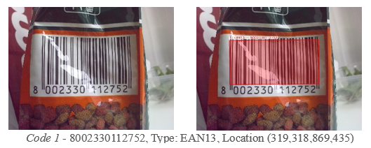
Figure 5 - EAN13 detection on cylindrical container surface with bright lighting.

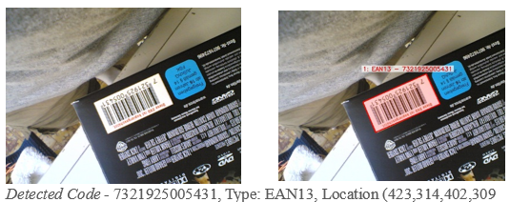
Figure 6 - EAN13 barcode detection on flipped and angled surface

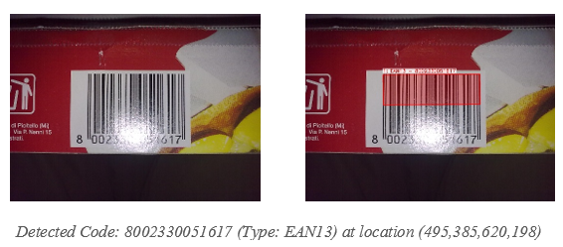
Figure 7 - EAN13 barcode detection despite bright lighting reflection

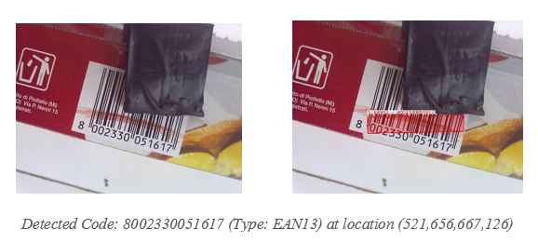
Figure 8 - EAN13 barcode detection despite partial blocking and red colour overlay.

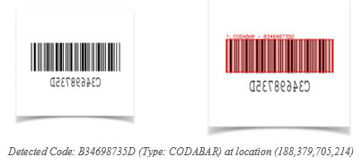
Figure 9 - CODABAR barcode detection overcomes vertical inversion

A.2 QR Code Detection:

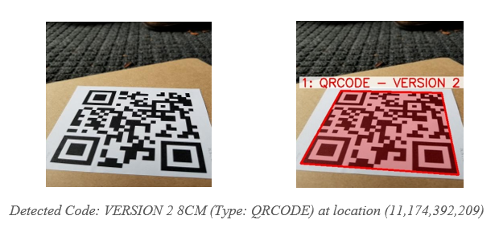
Figure 10 - QR code detection on rotated code orientation

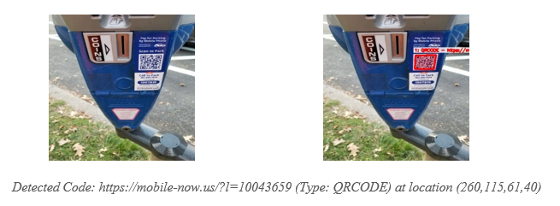
Figure 11 - QR code detection overcomes small size on distant triangular sign

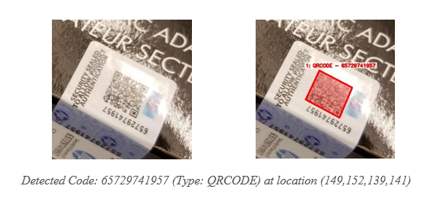
Figure 12 - QR code detection successful despite reflective glare and angled orientation

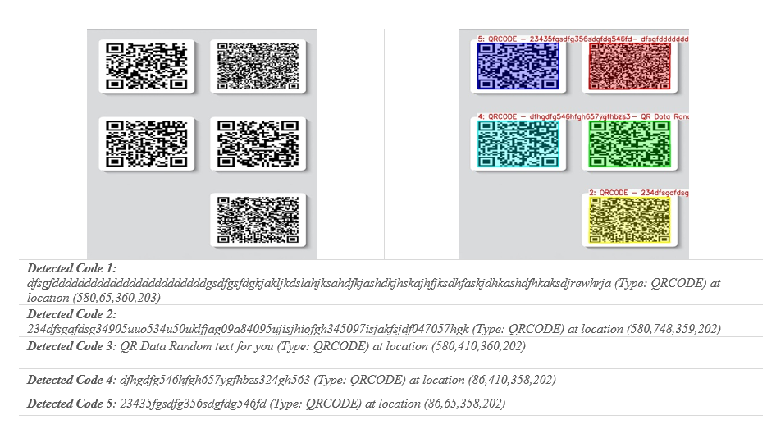
Figure 13 - Simultaneous detection of multiple QR codes in single image frame

A.3 Mixed Bar Code – QR Code Detection

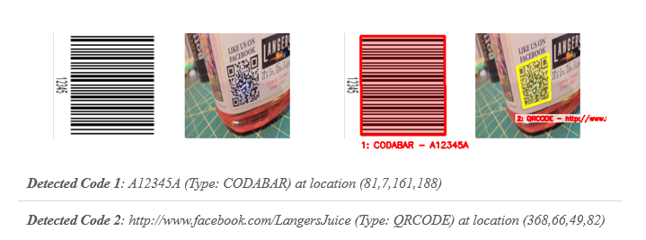
Figure 14 - CODABAR barcode and QR code detected together in mixed-code image

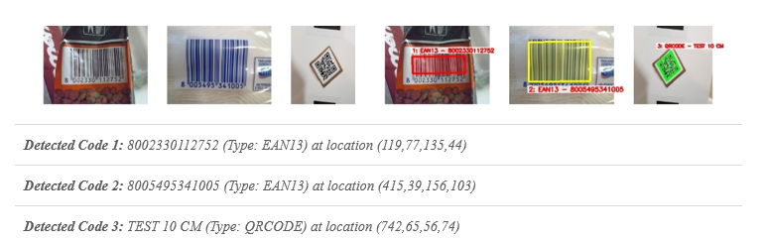
Figure 15 - Multi-code detection - 2 EAN13 barcodes and 1 QR code identified together

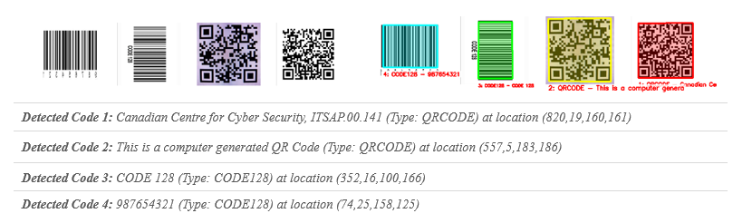
Figure 16 - Quad code detection successful - 2 barcodes and 2 QR codes recognized simultaneously

B. Pseudocode for Key Algorithms
Below is the pseudocode for the key algorithms implemented in our system.

B.1 Multi-Method Detection Pipeline
ALGORITHM: Multi-Method Detection
INPUT: Image I
OUTPUT: Set of detected code regions R

BEGIN
R_direct ← DirectDetection(I)
R_qr ← QRCodeDetection(I)
R_all ← R_direct ∪ R_qr

quality ← AssessImageQuality(I)

IF |R_all| = 0 OR quality < threshold THEN
I_preprocessed ← AdaptivePreprocessing(I)
E ← EdgeDetection(I_preprocessed)
R_edge ← FindCodeRegions(E, I)
R_gradient ← GradientDetection(I)
R_all ← R_all ∪ R_edge ∪ R_gradient
END IF

R_unique ← RemoveDuplicates(R_all)
R_filtered ← FilterFalsePositives(R_unique)

RETURN R_filtered
END

B.2 Adaptive Preprocessing
ALGORITHM: Adaptive Image Preprocessing
INPUT: Image I
OUTPUT: Enhanced image I_enhanced, Original grayscale I_gray

BEGIN
I_gray ← ConvertToGrayscale(I)
blur_level ← LaplacianVariance(I_gray)
has_glare ← DetectGlare(I_gray)

IF blur_level > clean_threshold AND NOT has_glare THEN
I_enhanced ← SimpleThresholding(I_gray)
ELSE
IF has_glare THEN
I_gray ← InpaintGlare(I_gray)
END IF

I_clahe ← CLAHE(I_gray, clip_limit, grid_size)
I_filtered ← BilateralFilter(I_clahe)

I_enhanced ← ZeroMatrix(size(I_filtered))
FOR each block_size IN [7, 11, 15, 19] DO
I_thresh ← AdaptiveThreshold(I_filtered, block_size)
I_enhanced ← I_enhanced OR I_thresh
END FOR
END IF

RETURN I_enhanced, I_gray
END

B.3 Multi-Scale Gradient Detection
ALGORITHM: Gradient-Based Region Detection
INPUT: Grayscale image I_gray, Original image I_orig
OUTPUT: Set of gradient regions R_grad

BEGIN
grad_x ← SobelX(I_gray)
grad_y ← SobelY(I_gray)
grad_magnitude ← Magnitude(grad_x, grad_y)

I_adaptive ← AdaptiveThreshold(grad_magnitude, MEAN_C)
I_binary ← BinaryThreshold(grad_magnitude, threshold)
I_combined ← I_adaptive OR I_binary

I_morph ← MorphologicalClose(I_combined, horizontal_kernel)
I_morph ← MorphologicalClose(I_morph, vertical_kernel)

contours ← FindContours(I_morph)
R_grad ← ∅

FOR each contour C IN contours DO
IF Area(C) ≥ min_area AND ValidAspectRatio(C) THEN
box ← MinAreaRect(C)
warped ← PerspectiveTransform(I_orig, box)
R_grad ← R_grad ∪ {box, warped}
END IF
END FOR

RETURN R_grad
END

B.4 QR Code Grid-Based Detection
ALGORITHM: Specialized QR Code Detection
INPUT: Image I
OUTPUT: Set of QR code regions R_qr

BEGIN
I_gray ← ConvertToGrayscale(I)
I_enhanced ← CLAHE(I_gray)
I_binary ← AdaptiveThreshold(I_enhanced)

h, w ← GetDimensions(I_gray)
grid_size ← min(w, h) / 3
R_qr ← ∅

FOR y = 0 TO h STEP grid_size DO
FOR x = 0 TO w STEP grid_size DO
roi ← ExtractROI(I_binary, x, y, grid_size)
roi_gray ← ExtractROI(I_gray, x, y, grid_size)
roi_sharp ← SharpenFilter(roi_gray)

test_images ← {roi, roi_gray, roi_sharp}

FOR each test_img IN test_images DO
decoded ← PyZBarDecode(test_img)
IF decoded.type = QRCODE THEN
points ← TransformCoordinates(decoded.polygon, x, y)
warped ← PerspectiveTransform(I, points)
R_qr ← R_qr ∪ {points, warped, decoded}
BREAK
END IF
END FOR
END FOR
END FOR

RETURN R_qr
END

B.5 Multi-Orientation Recognition
ALGORITHM: Adaptive Code Recognition
INPUT: Image region I_region
OUTPUT: Decoded result D or NULL

BEGIN
I_gray ← ConvertToGrayscale(I_region)
grad_x ← SobelX(I_gray)
grad_y ← SobelY(I_gray)

IF Sum(grad_y) > Sum(grad_x) × 1.5 THEN
rotation_angles ← {0°, 90°, -90°}
ELSE
rotation_angles ← {0°, 30°, 45°, -30°, -45°}
END IF

test_versions ← ∅
FOR each angle IN rotation_angles DO
I_rotated ← RotateImage(I_region, angle)
I_enhanced ← CLAHE(I_rotated)
I_adaptive ← AdaptiveThreshold(I_enhanced)
I_otsu ← OtsuThreshold(I_enhanced)
test_versions ← test_versions ∪ {I_rotated, I_enhanced, I_adaptive, I_otsu}
END FOR

FOR each version IN test_versions DO
D ← PyZBarDecode(version)
IF D ≠ NULL THEN
IF D.type = EAN13 AND ValidateChecksum(D.data) THEN
RETURN D
ELSE IF D.type ≠ EAN13 THEN
RETURN D
END IF
END IF
END FOR

RETURN NULL
END

B.6 False Positive Filtering
ALGORITHM: False Positive Elimination
INPUT: Set of regions R, Original image I
OUTPUT: Filtered regions R_filtered

BEGIN
R_decoded ← {r ∈ R : r has decoded data}
IF |R_decoded| > 0 THEN
RETURN R_decoded
END IF

img_area ← Width(I) × Height(I)
R_filtered ← ∅

FOR each region r IN R DO
region_area ← CalculateArea(r.box)

IF region_area < 0.0005 × img_area OR region_area > 0.95 × img_area THEN
CONTINUE
END IF

I_warped ← r.warped
vertical_lines ← CountVerticalLines(I_warped)

IF vertical_lines < 8 THEN
finder_patterns ← CountQRFinderPatterns(I_warped)
IF finder_patterns < 2 THEN
CONTINUE
END IF
END IF

R_filtered ← R_filtered ∪ {r}
END FOR

RETURN R_filtered
END

B.7 Comprehensive Performance Evaluation
ALGORITHM: Multi-Dimensional Performance Assessment
INPUT: Image path P, Processing result R, Processing time T
OUTPUT: Updated evaluation metrics

BEGIN
category ← DetermineImageCategory(P)
expected_types ← GetExpectedTypes(category)
detected_types ← ExtractDetectedTypes(R.recognized_codes)

// Detection Performance Metrics
IF category = "Both Barcode-QRCode" THEN
IF detected_types ∩ expected_types ≠ ∅ THEN
true_positives[category] ← true_positives[category] + 1
ELSE
false_negatives[category] ← false_negatives[category] + 1
END IF
ELSE
IF expected_types ⊆ detected_types THEN
true_positives[category] ← true_positives[category] + 1
ELSE IF detected_types ≠ ∅ THEN
false_positives[category] ← false_positives[category] + 1
ELSE
false_negatives[category] ← false_negatives[category] + 1
END IF
END IF

processing_times[category] ← processing_times[category] ∪ {T}

// Calculate consolidated metrics
precision ← tp / (tp + fp) if (tp + fp) > 0 else 0
recall ← tp / (tp + fn) if (tp + fn) > 0 else 0
f1_score ← 2 × precision × recall / (precision + recall) if (precision + recall) > 0 else 0

RETURN {precision, recall, f1_score}
END

C. Parameter Sensitivity Analysis
Systematic parameter optimization was conducted to establish optimal configuration values for the detection pipeline, examining performance sensitivity across critical components while balancing detection accuracy, computational efficiency, and false positive suppression.

Parameter | Tested Range | Optimal Value | Impact on Performance
Gaussian Blur Kernel | 3×3 – 11×11 | 5×5 | Larger kernels enhance noise robustness while preserving essential edge characteristics for code boundary detection
Canny Low Threshold | 25–100 | 40 | Lower values increase edge detection sensitivity, particularly beneficial for low-contrast code boundaries
Canny High Threshold | 100–300 | 120 | Optimized values maintain edge continuity while minimizing spurious edge artifacts
CLAHE Clip Limit | 1.5–4.0 | 2.5 | Higher values enhance local contrast adaptation without introducing excessive noise amplification
CLAHE Grid Size | 4×4 – 12×12 | 6×6 | Smaller grids provide finer local adaptation while maintaining computational tractability
Minimum Contour Area | 100–500 | 200 | Lower thresholds enable detection of smaller codes while increasing computational overhead
Aspect Ratio Range | 0.1–10.0 | 0.15–8.0 | Tighter constraints improve geometric validation while accommodating perspective distortions
IoU Threshold | 0.1–0.3 | 0.15 | Lower values enhance separation of closely positioned codes while preventing over-segmentation
Morphological Kernel | 8×8 – 20×20 | 12×12 | Intermediate sizes effectively connect fragmented edges without merging distinct code regions
Clean Image Threshold | 50–250 | 150 | Higher values accurately identify high-quality images for simplified processing pathways
Table 6 - Parameter Sensitivity Analysis
The empirical analysis revealed that preprocessing parameters exhibit the greatest influence on overall system performance, particularly for challenging imaging conditions. The Canny edge detection thresholds (40/120) maintain optimal balance between sensitivity and noise rejection, while CLAHE parameters (clip limit 2.5, grid size 6×6) provide effective contrast enhancement without artifacts.
Geometric validation parameters directly affect the balance between detection sensitivity and the suppression of false positives. The aspect ratio range (0.15-8.0) was accepted as optimal because it accommodates diverse code formats and filters background textures. The threshold for IoU (0.15) facilitates effective separation of closely positioned codes while preserving valid detections.
These results emphasize that choosing parameters involves balancing detection sensitivity and false rejection rate relative to resource consumption. The valid configuration is strongly tailored to the particular context of the problem and the anticipated surrounding conditions.

D. Code Snippets for Key System Components

D.1 Code Snippet 1 - Adaptive Multi-Scale Preprocessing Pipeline
This image preprocessing framework modifies the parameters of enhancement dynamics according to the qualitative assessment of the image during processing, taking into consideration the extent of visibility of the code over varying light and noise levels.
def preprocess_image(self, image):
"""Enhanced preprocessing with optimized parameters"""
gray = cv2.cvtColor(image, cv2.COLOR_BGR2GRAY) if len(image.shape) == 3 else image.copy()

# Assess image quality to determine processing path
blur_level = cv2.Laplacian(gray, cv2.CV_64F).var()
has_glare = self._detect_glare(gray)

if blur_level > self.clean_image_threshold and not has_glare:
# Simple preprocessing for clean images
blurred = cv2.GaussianBlur(gray, (3, 3), 0)
thresh = cv2.adaptiveThreshold(
blurred, 255, cv2.ADAPTIVE_THRESH_GAUSSIAN_C,
cv2.THRESH_BINARY_INV, 9, 2
)
return thresh, gray

# Enhanced processing for challenging images
if has_glare:
_, glare_mask = cv2.threshold(gray, 225, 255, cv2.THRESH_BINARY)
glare_mask = cv2.dilate(glare_mask, np.ones((2, 2), np.uint8), iterations=1)
gray = cv2.inpaint(gray, glare_mask, 2, cv2.INPAINT_TELEA)

# Multi-scale adaptive thresholding with better block sizes
clahe = cv2.createCLAHE(clipLimit=self.clahe_clip_limit, tileGridSize=self.clahe_grid_size)
enhanced = clahe.apply(gray)
filtered = cv2.bilateralFilter(enhanced, 5, 40, 40)

block_sizes = [7, 11, 15, 19]
combined_thresh = np.zeros_like(filtered)
for block_size in block_sizes:
thresh1 = cv2.adaptiveThreshold(
filtered, 255, cv2.ADAPTIVE_THRESH_GAUSSIAN_C,
cv2.THRESH_BINARY_INV, block_size, 2
)
combined_thresh = cv2.bitwise_or(combined_thresh, thresh1)

return combined_thresh, gray

D.2 Code Snippet 2 - Intelligent Boundary Refinement with Multi-Epsilon Approximation
The segmentation algorithm employs sophisticated polygon approximation techniques with
multiple epsilon values to achieve optimal boundary fitting while maintaining computational
efficiency through content-aware refinement strategies.
def find_code_regions(self, edge_img, original_img):
"""Improved region detection with better boundary fitting"""
contours, _ = cv2.findContours(edge_img, cv2.RETR_EXTERNAL, cv2.CHAIN_APPROX_SIMPLE)
code_regions = []

for contour in contours:
if cv2.contourArea(contour) < self.min_contour_area:
continue

# Multi-epsilon polygon approximation for optimal boundaries
peri = cv2.arcLength(contour, True)
epsilon_values = [0.01, 0.015, 0.02, 0.025, 0.03]
best_approx = None
best_score = float('-inf')

for epsilon in epsilon_values:
approx = cv2.approxPolyDP(contour, epsilon * peri, True)
corner_score = 10 if len(approx) == 4 else max(0, 8 - abs(len(approx) - 4))

if len(approx) >= 3:
rect_approx = cv2.minAreaRect(approx)
rect_area = rect_approx[1][0] * rect_approx[1][1]
contour_area_approx = cv2.contourArea(approx)
rectangularity = contour_area_approx / rect_area if rect_area > 0 else 0
score = corner_score + rectangularity * 8

if score > best_score:
best_score = score
best_approx = approx

# Content-based boundary refinement
box = self._order_points(best_approx.reshape(-1, 2))
M = cv2.getPerspectiveTransform(box.astype("float32"), dst_pts)
warped = cv2.warpPerspective(original_img, M, (width, height))

if warped.size > 0:
warped_gray = cv2.cvtColor(warped, cv2.COLOR_BGR2GRAY) if len(warped.shape) == 3 else warped
_, binary = cv2.threshold(warped_gray, 200, 255, cv2.THRESH_BINARY_INV)
coords = cv2.findNonZero(binary)

if coords is not None and len(coords) > 50:
x, y, w, h = cv2.boundingRect(coords)
padding_x = max(3, int(w * 0.05))
padding_y = max(3, int(h * 0.05))
refined_warped = warped[y-padding_y:y+h+padding_y, x-padding_x:x+w+padding_x]

code_regions.append({'box': box, 'warped': refined_warped, 'rect': rect})

return code_regions

D.3 Code Snippet 3 - Grid-Based QR Code Detection with Spatial Decomposition
This specialized detection algorithm implements systematic spatial grid analysis combined with multiple preprocessing variations to ensure comprehensive QR code detection in complex scenarios with multiple codes present.
def detect_qr_codes(self, image):
"""Improved QR code detection with optimized parameters"""
gray = cv2.cvtColor(image, cv2.COLOR_BGR2GRAY) if len(image.shape) == 3 else image.copy()

clahe = cv2.createCLAHE(clipLimit=2.0, tileGridSize=(6, 6))
enhanced = clahe.apply(gray)
binary = cv2.adaptiveThreshold(
enhanced, 255, cv2.ADAPTIVE_THRESH_GAUSSIAN_C,
cv2.THRESH_BINARY, 9, 2
)

# Grid-based search for multiple QR codes
qr_regions = []
h, w = gray.shape[:2]
grid_size = min(w, h) // 3

for y in range(0, h, grid_size):
for x in range(0, w, grid_size):
roi_width = min(grid_size * 2, w - x)
roi_height = min(grid_size * 2, h - y)

if roi_width <= 0 or roi_height <= 0:
continue

roi = binary[y:y+roi_height, x:x+roi_width]
roi_gray = gray[y:y+roi_height, x:x+roi_width]

# Multiple preprocessing variations
kernel = np.array([[-1,-1,-1], [-1,9,-1], [-1,-1,-1]])
sharpened = cv2.filter2D(roi_gray, -1, kernel)
test_images = [roi, roi_gray, sharpened]

for test_img in test_images:
decoded = decode_silent(test_img)
if decoded:
for qr in decoded:
if qr.type == 'QRCODE':
points = np.array([(p.x + x, p.y + y) for p in qr.polygon], dtype=np.int32)
points = self._order_points(points)

M = cv2.getPerspectiveTransform(src_pts, dst_pts)
warped = cv2.warpPerspective(image, M, (width, height))

qr_regions.append({
'box': points, 'warped': warped, 'rect': rect,
'decoded': {'type': qr.type, 'data': qr.data.decode('utf-8')}
})
break

return qr_regions

D.4 Code Snippet 4 - Multi-Orientation Recognition with Gradient-Based Rotation Analysis
The recognition system implements intelligent rotation detection through gradient analysis, systematically testing multiple orientations and preprocessing variations to maximize decoding success rates across diverse code presentations.
def decode(self, image):
"""Enhanced decode method with optimized preprocessing"""
if len(image.shape) == 3:
gray = cv2.cvtColor(image, cv2.COLOR_BGR2GRAY)
else:
gray = image.copy()

# Gradient-based rotation analysis
sobel_x = cv2.Sobel(gray, cv2.CV_64F, 1, 0, ksize=3)
sobel_y = cv2.Sobel(gray, cv2.CV_64F, 0, 1, ksize=3)
abs_sobel_x = cv2.convertScaleAbs(sobel_x)
abs_sobel_y = cv2.convertScaleAbs(sobel_y)

sum_x = np.sum(abs_sobel_x)
sum_y = np.sum(abs_sobel_y)

rotated_images = [image]
h, w = gray.shape[:2]

# Selective rotation based on gradient dominance
if sum_y > sum_x * 1.5:
center = (w // 2, h // 2)
for angle in [90, -90]:
M = cv2.getRotationMatrix2D(center, angle, 1.0)
rotated = cv2.warpAffine(image, M, (w, h), borderMode=cv2.BORDER_CONSTANT, borderValue=255)
rotated_images.append(rotated)

# Create enhanced versions for each orientation
all_versions = []
for rot_img in rotated_images:
rot_gray = cv2.cvtColor(rot_img, cv2.COLOR_BGR2GRAY) if len(rot_img.shape) == 3 else rot_img

clahe = cv2.createCLAHE(clipLimit=2.5, tileGridSize=(6, 6))
enhanced = clahe.apply(rot_gray)

binary_adaptive = cv2.adaptiveThreshold(
enhanced, 255, cv2.ADAPTIVE_THRESH_GAUSSIAN_C,
cv2.THRESH_BINARY_INV, 9, 2
)
_, binary_otsu = cv2.threshold(enhanced, 0, 255, cv2.THRESH_BINARY + cv2.THRESH_OTSU)

all_versions.extend([rot_img, rot_gray, enhanced, binary_adaptive, binary_otsu])

# Systematic decoding with validation
for v in all_versions:
decoded = decode_silent(v)
if decoded:
for d in decoded:
decoded_data = d.data.decode('utf-8')
if d.type == 'EAN13':
if len(decoded_data) == 13 and self._validate_ean13_checksum(decoded_data):
return {'type': d.type, 'data': decoded_data, 'polygon': d.polygon}
else:
return {'type': d.type, 'data': decoded_data, 'polygon': d.polygon}

return None

D.5 Code Snippet 5 - Comprehensive Performance Evaluation Framework
This evaluation system provides real-time multi-dimensional performance assessment, implementing sophisticated metrics calculation for detection accuracy, segmentation precision, and recognition success rates across different code categories.
def evaluate_detection_performance(self, image_path, result, processing_time):
"""Fixed detection performance evaluation"""
category = self.determine_image_category(image_path)
self.processed_folders.add(category)
self.detection_results[category]['times'].append(processing_time * 1000)

# Determine expected vs actual detection
expected_types = set()
if category == 'Barcode':
expected_types.add('Barcode')
elif category == 'QR Code':
expected_types.add('QR Code')
elif category == 'Both Barcode-QRCode':
expected_types.update(['Barcode', 'QR Code'])

# Determine what was actually detected
detected_types = set()
if result and result.get('success') and result.get('recognized_codes'):
for code in result['recognized_codes']:
if code['type'] in ['EAN13', 'EAN8', 'CODE128', 'CODE39']:
detected_types.add('Barcode')
elif code['type'] == 'QRCODE':
detected_types.add('QR Code')

# Calculate TP, FP, FN based on expected vs detected
if category == 'Both Barcode-QRCode':
if detected_types.intersection(expected_types):
self.detection_results[category]['tp'] += 1
else:
self.detection_results[category]['fn'] += 1
else:
if expected_types.issubset(detected_types):
self.detection_results[category]['tp'] += 1
elif detected_types:
self.detection_results[category]['fp'] += 1
else:
self.detection_results[category]['fn'] += 1

def calculate_metrics(self):
"""Calculate comprehensive performance metrics"""
for category in self.processed_folders:
data = self.detection_results[category]
tp, fp, fn = data['tp'], data['fp'], data['fn']
times = data['times']

precision = tp / (tp + fp) if (tp + fp) > 0 else 0
recall = tp / (tp + fn) if (tp + fn) > 0 else 0
f1_score = 2 * precision * recall / (precision + recall) if (precision + recall) > 0 else 0
success_rate = tp / (tp + fn) if (tp + fn) > 0 else 0
avg_time = statistics.mean(times) if times else 0

self.results[category] = {
'Precision': f"{precision:.1%}",
'Recall': f"{recall:.1%}",
'F1-Score': f"{f1_score:.1%}",
'Success Rate': f"{success_rate:.1%}",
'Average Processing Time (ms)': f"{avg_time:.1f}"
}
return self.results

